Document Overview:

1. Docker and you
2. Building Tracking First and TF-Node with Docker
3. Using the built in tests portion of Tracking First
4. Continuous release notes
5. Helpful Docker Commands
6. Other Notes

1. Docker and You:

You should be comfortable with using docker before getting started with any
project that will use it. Please see the docker website documentation specific to the tool.
Also view some of the forums for extra notes on how-tos and other notes. Specifically
see the docker github site and other programmer sites (stackoverflow.com, superuser.com
and forums.docker.com) for any bugs that might be in docker currently and could be show
stoppers for anything that is list ed below. If you stick with the guidelines below should
be fine at the time of this writing. For helpful docker commands see the end of this doc.

2. Build Tracking First and TF-Node with Docker:

        - Download Docker-Toolbox for Windows or OSX
        - Install Docker-Toolbox on your specific environment

        - During the install take all the defaults (see below)

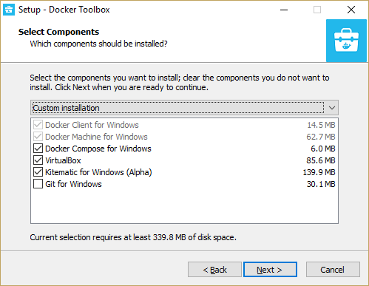
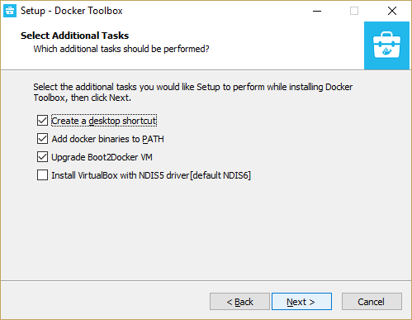
4. Make sure COMPOSE_CONVERT_WINDOWS_PATHS is defined
as an evironmental variable and set to 1. Also make sure it should still be
a 1 on windows as it seems to have changed over time.
'
5. Retrieve/download the Tracking First and TF-Node repositories from github.
The repositories will be downloaded to your Users folder and it should remain
due to the folder sharing that takes place with docker.

6. In the TF-Node project go to the Models folder and rename the
config.docker.json file to config.json. Notice the PORT value near the top
of the file. The default value is 8099. This port will be used for the Tracking
First PHP project to talk to the TF-Node project since the latter owns the
Mongo database, which they both need.

7. Go to the Tracking First project app/config folder and open the file
parameters.yml.docker and make sure the port value is the same in the node
js host value.

nodejs_host: 'http://192.168.99.100:8099'

8. Note the IP Address of the node js host at 192.168.99.100. This address
is the first address that docker provides when setting up images and containers.
It's also the address both projects expect to be exist under. If for any reason a
docker virtual machine is added or removed you will no longer be at this address.
So keep an eye on the docker toolboxes startup IP Address. If its not correct delete
all docker virtual machines completely and restart your computer to be completely
clean at startup.

9. Open a command prompt or terminal and go to the TF-Node project. If on
a windows machine make sure to use linux folder slashes '/' while in Docker and
not windows slashes '\'.

10. Run docker-compose on TF-Node it'll run for a few minutes and should
complete and start running. Below is a screenshot of a clean docker-compose run.
If you have any problems it'll be with the phantomizer and you might have to
re-compose the docker image. Ignore any node js outdated module notes.

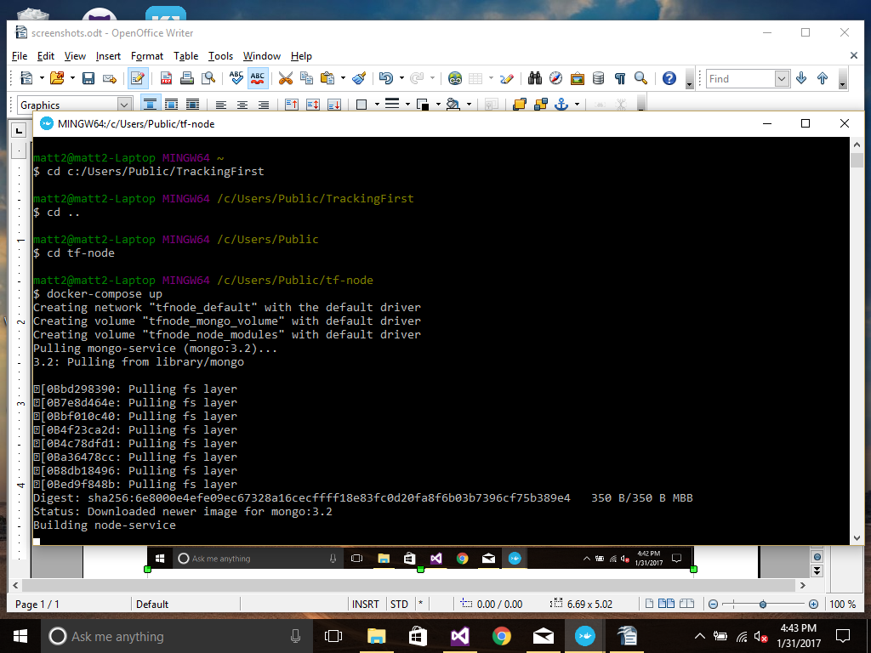

11. After about 3 minutes run docker-compose on the Tracking First repository.
You may see some PHP failures which should be fine and if you see a failure to
move the project into place check Step 4 again.

12. Stick with Docker toolbox for now because docker for windows
isn't cooked enough yet at the time of this writing. Also these
insructions should work for OSX as its closer to linux than Windows
is and it could be much simplier on Linux

13. If you need to move files around simply use Docker to get to the Vms
/bin/bash and then you can do whatever is needed.

14. Don't bother looking at the Docker VM through virtual box as it is
completely stripped of all GUI functionality.

As a final note it would seem to be simpler just to run Docker on a Linux box
or Linux VM; however, that is not the case that I've seen. The problem though is
getting all the proper libraries together for docker as the linux distributions don't
have the best connectivity with each other and usually can't find the DLLs or LIBs
that are actually needed. This is also the same for Docker that finding all the components
that work together can become a true nightmare. Because of the release process for
Linux distributions seem to be a year behind on some version of Linux.

3. Using the built in tests

Currently the tf-node tests include a source and unit test file pairing for each file
in the project and some module style tests. They are self-explanatory and pretty easy
just route to the tests to use them. The PHP tests are a bit thin but are there no the less.

The PHP project still has the Demo Bundle portion of the project still in it and it should
be ignored. The Demo is automatically added to any Symfony project to show how the
internals of the framework function and thats about it. In this case it can be completely
ignored except for pointing out the flow control and routing of a Symfony project.

The Main Bundle is the actual application and defines the controllers, routes and views
for the web service itself. Its layed out and seems to lack some logic because most of
the logic is broken up in the many layers that make up the app and some logic is hidden
in the tags. Then there is the logic that the framework adds to it when the code is
generated. The Test Bundle is self-explanatory its a bit thin but it does the job none the less.

As for local debugging it seems that PHPStorm is the best product to use as it has a Symfony
plugin that takes care of most of heavy lifting for you. You can also do all your debugging
inside the docker container when it syncs properly.

4. Complete and Thorough testing

TODO:

5. Continuous release notes

TODO:

6. Helpful Docker Commands

docker-compose up
Build a docker image then create a container and start the container

docker ps
List all containers

docker images
List all images

docker run -it <image ##> /bin/bash
Turn an image into a container and start the container

docker save <image ##> -o name.tar
Save an image from the VM to your computer

docker export <container ##> --force
Save a container from the VM to your computer

docker import name.tar
Import a previously export tarball back into a container in the VM.

docker create <image ##>
Create a container from an image

docker kill <container ##>
Kill a container(s)

docker rm <container ##>
Delete / remove a container

docker rmi <image ##>
Delete / remove an image

Docker Engine Cmds:

service docker stop
service docker status
service docker start

Example Run Commands:

docker run -d --name=mongo2 -v /data/mongodb:/data2/db -p 192.168.99.100:27017:27017 mongo:3.2 -smallfiles --rest –httpinterface

Get Docker Engine log file:

docker-machine scp default:/var/log/docker.log ./

Set Docker log file size:

OPTIONS='--insecure-registry=172.30.0.0/16 --selinux-enabled --log-opt max-size=50m
--log-opt max-file=5'

